THE SHORT-RUN TRADE-OFF BETWEEN INFLATION AND UNEMPLOYMENT
35

WHAT’S NEW IN THE SEVENTH EDITION:

The section on ”A Financial Crisis Takes Us for a Ride Along the Phillips Curve” has been updated.

LEARNING OBJECTIVES:

By the end of this chapter, students should understand:

➢ why policymakers face a short-run trade-off between inflation and unemployment.

➢ why the inflation-unemployment trade-off disappears in the long run.

➢ how supply shocks can shift the inflation-unemployment trade-off.

➢ the short-run cost of reducing inflation.

➢ how policymakers’ credibility might affect the cost of reducing inflation.

CONTEXT AND PURPOSE:

Chapter 22 is the final chapter in a three-chapter sequence on the economy’s short-run fluctuations around its long-term trend. Chapter 20 introduced aggregate supply and aggregate demand. Chapter 21 developed how monetary and fiscal policies affect aggregate demand. Both Chapters 20 and 21 addressed the relationship between the price level and output. Chapter 22 will concentrate on a similar relationship between inflation and unemployment.
The purpose of Chapter 22 is to trace the history of economists’ thinking about the relationship between inflation and unemployment. Students will see why there is a temporary trade-off between inflation and unemployment, and why there is no permanent trade-off. This result is an extension of the results produced by the model of aggregate supply and aggregate demand where a change in the price level induced by a change in aggregate demand temporarily alters output but has no permanent impact on output.

KEY POINTS:

• The Phillips curve describes a negative relationship between inflation and unemployment. By expanding aggregate demand, policymakers can choose a point on the Phillips curve with higher inflation and lower unemployment. By contracting aggregate demand, policymakers can choose a point on the Phillips curve with lower inflation and higher unemployment.

• The trade-off between inflation and unemployment described by the Phillips curve holds only in the short run. In the long run, expected inflation adjusts to changes in actual inflation, and the short-run Phillips curve shifts. As a result, the long-run Phillips curve is vertical at the natural rate of unemployment.

• The short-run Phillips curve also shifts because of shocks to aggregate supply. An adverse supply shock, such as an increase in world oil prices, gives policymakers a less favorable trade-off between inflation and unemployment. That is, after an adverse supply shock, policymakers have to accept a higher rate of inflation for any given rate of unemployment, or a higher rate of unemployment for any given rate of inflation.

• When the Fed contracts growth in the money supply to reduce inflation, it moves the economy along the short-run Phillips curve, which results in temporarily high unemployment. The cost of disinflation depends on how quickly expectations of inflation fall. Some economists argue that a credible commitment to low inflation can reduce the cost of disinflation by inducing a quick adjustment of expectations.

CHAPTER OUTLINE:

I. The Phillips Curve

A. Origins of the Phillips Curve

1. In 1958, economist A. W. Phillips published an article discussing the negative correlation between inflation rates and unemployment rates in the United Kingdom.

2. American economists Paul Samuelson and Robert Solow showed a similar relationship between inflation and unemployment for the United States two years later.

3. The belief was that low unemployment is related to high aggregate demand, and high aggregate demand puts upward pressure on prices. Likewise, high unemployment is related to low aggregate demand, and low aggregate demand pulls price levels down.

4. Definition of Phillips curve: a curve that shows the short-run trade-off between inflation and unemployment.

Figure 1

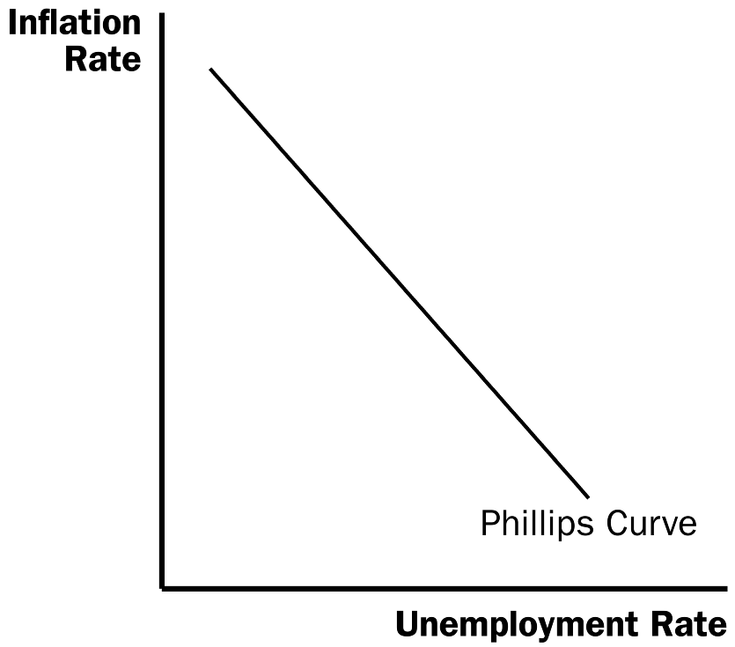

5. Samuelson and Solow believed that the Phillips curve offered policymakers a menu of possible economic outcomes. Policymakers could use monetary and fiscal policy to choose any point on the curve.

B. Aggregate Demand, Aggregate Supply, and the Phillips Curve


Show how the Phillips curve is derived from the aggregate demand/aggregate supply model step by step. This graph is different from all the other graphs that they have drawn in macroeconomics, because it is not a supply-and-demand diagram.

1. The Phillips curve shows the combinations of inflation and unemployment that arise in the short run as shifts in the aggregate-demand curve move the economy along the short-run aggregate-supply curve.

2. The greater the aggregate demand for goods and services, the greater the economy’s output and the higher the price level. Greater output means lower unemployment. The higher the price level in the current year, the higher the rate of inflation.

3. Example: The price level is 100 (measured by the Consumer Price Index) in the year 2020. There are two possible changes in the economy for the year 2021: a low level of aggregate demand or a high level of aggregate demand.

a. If the economy experiences a low level of aggregate demand, we would be at a short-run equilibrium like point A. This point also corresponds with point A on the Phillips curve. Note that when aggregate demand is low, the inflation rate is relatively low and the unemployment rate is relatively high.

b. If the economy experiences a high level of aggregate demand, we would be at a short-run equilibrium like point B. This point also corresponds with point B on the Phillips curve. Note that when aggregate demand is high, the inflation rate is relatively high and the unemployment rate is relatively low.

Figure 2

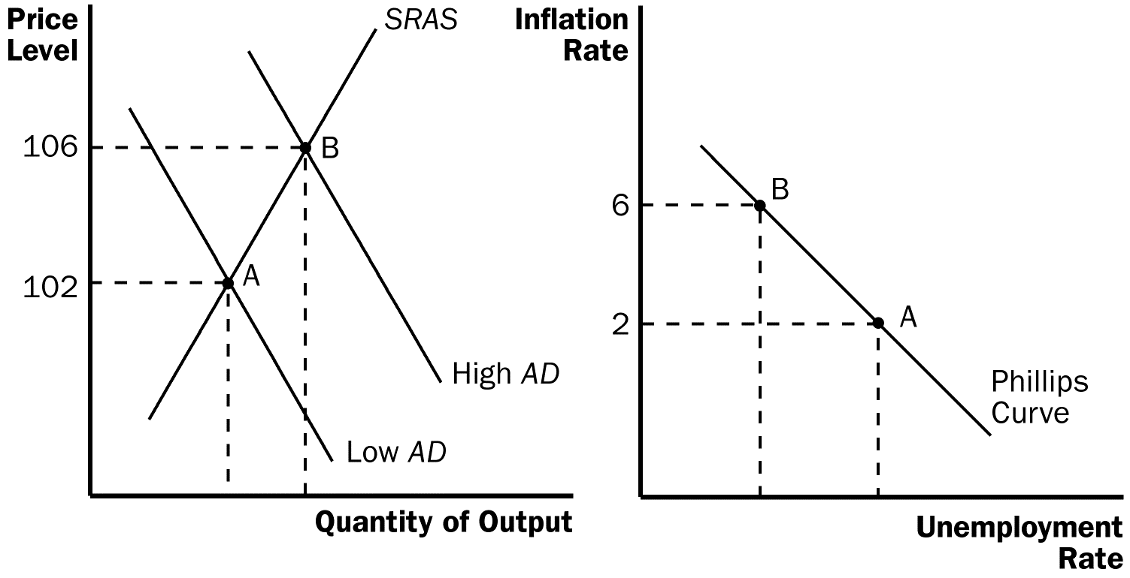

4. Because monetary and fiscal policies both shift the aggregate-demand curve, these policies can move the economy along the Phillips curve.

a. Increases in the money supply, increases in government spending, or decreases in taxes all increase aggregate demand and move the economy to a point on the Phillips curve with lower unemployment and higher inflation.

b. Decreases in the money supply, decreases in government spending, or increases in taxes all lower aggregate demand and move the economy to a point on the Phillips curve with higher unemployment and lower inflation.

II. Shifts in the Phillips Curve: The Role of Expectations

A. The Long-Run Phillips Curve

1. In 1968, economist Milton Friedman argued that monetary policy is only able to choose a combination of unemployment and inflation for a short period of time. At the same time, economist Edmund Phelps wrote a paper suggesting the same thing.

2. In the long run, monetary growth has no real effects. This implies that it cannot affect the factors that determine the economy’s long-run unemployment rate.

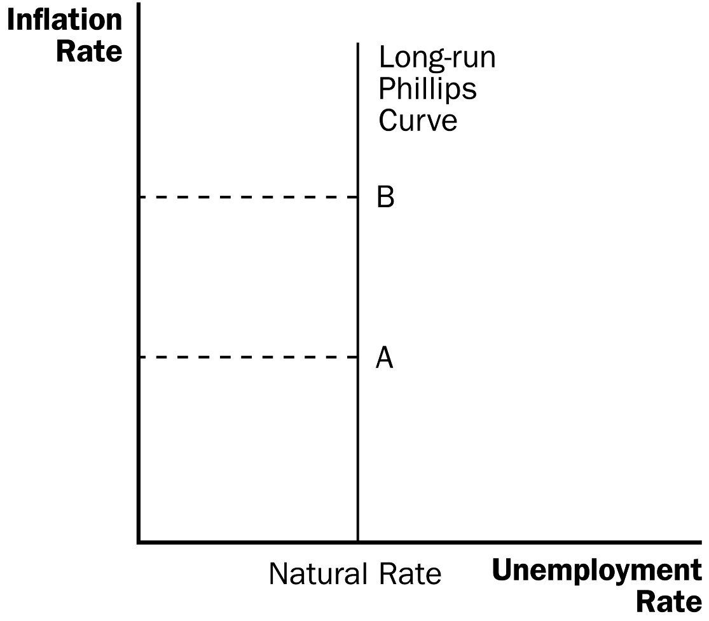

Figure 3

3. Thus, in the long run, we would not expect there to be a relationship between unemployment and inflation. This must mean that, in the long run, the Phillips curve is vertical.

Figure 4

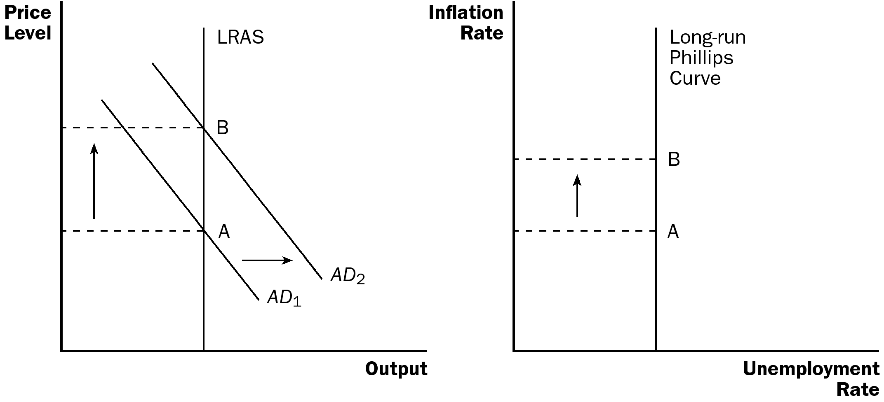

4. The vertical Phillips curve occurs because, in the long run, the aggregate supply curve is vertical as well. Thus, increases in aggregate demand lead only to changes in the price level and have no effect on the economy’s level of output. Thus, in the long run, unemployment will not change when aggregate demand changes, but inflation will.

5. The long-run aggregate-supply curve occurs at the economy’s natural level of output. This means that the long-run Phillips curve occurs at the natural rate of unemployment.

You may want to review what is meant by the “natural rate” of unemployment.

B. The Meaning of “Natural”

1. Friedman and Phelps considered the natural rate of unemployment to be the rate toward which the economy gravitates in the long run.

2. The natural rate of unemployment may not be the socially desirable rate of unemployment.

3. The natural rate of unemployment may change over time.

C. Reconciling Theory and Evidence

1. The conclusion of Friedman and Phelps that there is no long-run trade-off between inflation and unemployment was based on theory, while the correlation between inflation and unemployment found by Phillips, Samuelson, and Solow was based on actual evidence.

2. Friedman and Phelps believed that an inverse relationship between inflation and unemployment exists in the short run.

3. The long-run aggregate-supply curve is vertical, indicating that the price level does not influence output in the long run.

4. But, the short-run aggregate-supply curve is upward sloping because of misperceptions about relative prices, sticky wages, and sticky prices. These perceptions, wages, and prices adjust over time, so that the positive relationship between the price level and the quantity of goods and services supplied occurs only in the short run.

5. This same logic applies to the Phillips curve. The trade-off between inflation and unemployment holds only in the short run.

6. The expected level of inflation is an important factor in understanding the difference between the long-run and the short-run Phillips curves. Expected inflation measures how much people expect the overall price level to change.

7. The expected rate of inflation is one variable that determines the position of the short-run aggregate-supply curve. This is true because the expected price level affects the perceptions of relative prices that people form and the wages and prices that they set.

8. In the short run, expectations are somewhat fixed. Thus, when the Fed increases the money supply, aggregate demand increases along the upward sloping short-run aggregate-supply curve. Output grows (unemployment falls) and the price level rises (inflation increases).

9. Eventually, however, people will respond by changing their expectations of the price level. Specifically, they will begin expecting a higher rate of inflation.

D. The Short-Run Phillips Curve

1. We can relate the actual unemployment rate to the natural rate of unemployment, the actual inflation rate, and the expected inflation rate using the following equation:

a. Because expected inflation is already given in the short run, higher actual inflation leads to lower unemployment.

b. How much unemployment changes in response to a change in inflation is determined by the variable a, which is related to the slope of the short-run aggregate-supply curve.
Be sure to discuss why actual inflation always equals expected inflation along the long-run Phillips curve.

Figure 5

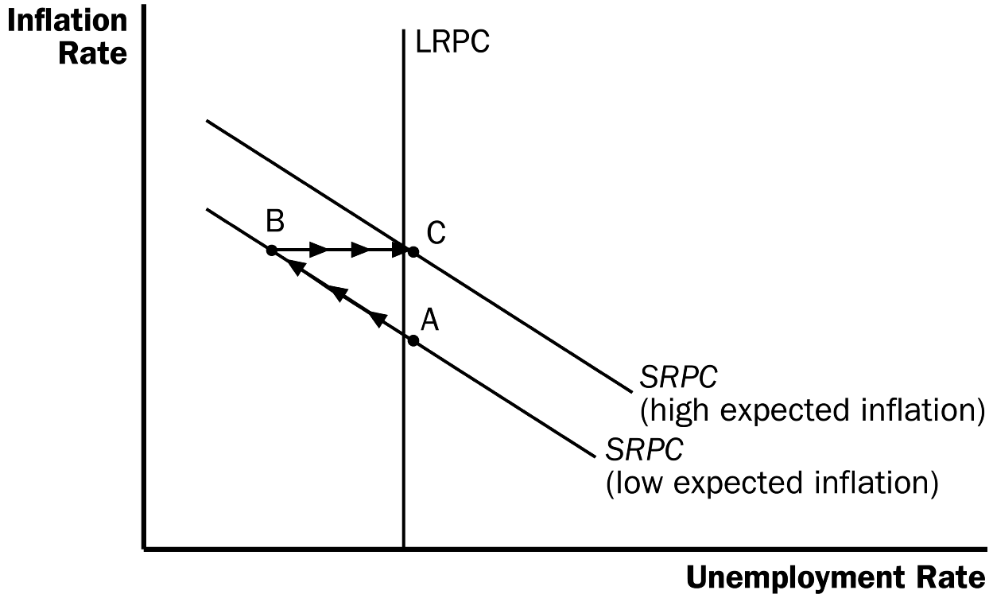

2. If policymakers want to take advantage of the short-run trade-off between unemployment and inflation, it may lead to negative consequences.

a. Suppose the economy is at point A and policymakers wish to lower the unemployment rate. Expansionary monetary policy or fiscal policy is used to shift aggregate demand to the right. The economy moves to point B, with a lower unemployment rate and a higher rate of inflation.

b. Over time, people get used to this new level of inflation and raise their expectations of inflation. This leads to an upward shift of the short-run Phillips curve. The economy ends up at point C, with a higher inflation rate than at point A, but the same level of unemployment.

E. The Natural Experiment for the Natural-Rate Hypothesis

1. Definition of the natural-rate hypothesis: the claim that unemployment eventually returns to its normal, or natural rate, regardless of the rate of inflation.

Figure 6

2. Figure 6 shows the unemployment and inflation rates from 1961 to 1968. It is easy to see the inverse relationship between these two variables.

3. Beginning in the late 1960s, the government followed policies that increased aggregate demand.

a. Government spending rose because of the Vietnam War.

b. The Fed increased the money supply to try to keep interest rates down.

4. As a result of these policies, the inflation rate remained fairly high. However, even though inflation remained high, unemployment did not remain low.

Figure 7

a. Figure 7 shows the unemployment and inflation rates from 1961 to 1973. The simple inverse relationship between these two variables began to disappear around 1970.

b. Inflation expectations adjusted to the higher rate of inflation and the unemployment rate returned to its natural rate of around 5% to 6%.

III. Shifts in the Phillips Curve: The Role of Supply Shocks

A. In 1974, OPEC increased the price of oil sharply. This increased the cost of producing many goods and services and therefore resulted in higher prices.

1. Definition of supply shock: an event that directly alters firms’ costs and prices, shifting the economy’s aggregate-supply curve and thus the Phillips curve.

2. Graphically, we could represent this supply shock as a shift in the short-run aggregate-supply curve to the left.

3. The decrease in equilibrium output and the increase in the price level left the economy with stagflation.

Figure 8

Price
Level
Inflation
Rate
AS₂

AS₁

AD
PC₂

PC₁

Output
Unemployment Rate

B. Given this turn of events, policymakers are left with a less favorable short-run trade-off between unemployment and inflation.

1. If they increase aggregate demand to fight unemployment, they will raise inflation further.

2. If they lower aggregate demand to fight inflation, they will raise unemployment further.

C. This less favorable trade-off between unemployment and inflation can be shown by a shift of the short-run Phillips curve. The shift may be permanent or temporary, depending on how people adjust their expectations of inflation.

D. During the 1970s, the Fed decided to accommodate the supply shock by increasing the supply of money. This increased the level of expected inflation. Figure 9 shows inflation and unemployment in the United States during the late 1970s and early 1980s.

Figure 9

IV. The Cost of Reducing Inflation

A. The Sacrifice Ratio

1. To reduce the inflation rate, the Fed must follow contractionary monetary policy.

a. When the Fed slows the rate of growth of the money supply, aggregate demand falls.

b. This reduces the level of output in the economy, increasing unemployment.

c. The economy moves from point A along the short-run Phillips curve to point B, which has a lower inflation rate but a higher unemployment rate.

d. Over time, people begin to adjust their inflation expectations downward and the short-run Phillips curve shifts. The economy moves from point B to point C, where inflation is lower and the unemployment rate is back to its natural rate.

Figure 10

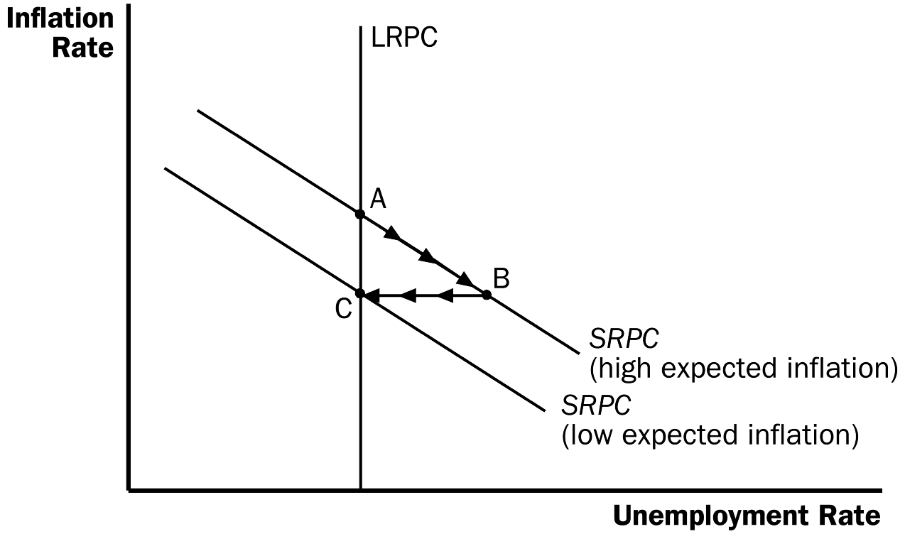

2. Therefore, to reduce inflation, the economy must suffer through a period of high unemployment and low output.

3. Definition of sacrifice ratio: the number of percentage points of annual output lost in the process of reducing inflation by one percentage point.

4. A typical estimate of the sacrifice ratio is five. This implies that for each percentage point inflation is decreased, output falls by 5%.

B. Rational Expectations and the Possibility of Costless Disinflation

1. Definition of rational expectations: the theory according to which people optimally use all the information they have, including information about government policies, when forecasting the future.

2. Proponents of rational expectations believe that when government policies change, people alter their expectations about inflation.

3. Therefore, if the government makes a credible commitment to a policy of low inflation, people would be rational enough to lower their expectations of inflation immediately. This implies that the short-run Phillips curve would shift quickly without any extended period of high unemployment.

C. The Volcker Disinflation

Figure 11

1. Figure 11 shows the inflation and unemployment rates that occurred while Paul Volcker worked at reducing the level of inflation during the 1980s.

2. As inflation fell, unemployment rose. In fact, the United States experienced its deepest recession since the Great Depression.

3. Some economists have offered this as proof that the idea of a costless disinflation suggested by rational-expectations theorists is not possible. However, there are two reasons why we might not want to reject the rational-expectations theory so quickly.

a. The cost (in terms of lost output) of the Volcker disinflation was not as large as many economists had predicted.

b. While Volcker promised that he would fight inflation, many people did not believe him. Few people thought that inflation would fall as quickly as it did; this likely kept the short-run Phillips curve from shifting quickly.

D. The Greenspan Era

Figure 12

1. Figure 12 shows the inflation and unemployment rate from 1984 to 2005, called the Greenspan era because Alan Greenspan became the chairman of the Federal Reserve in 1987.

2. In 1986, OPEC’s agreement with its members broke down and oil prices fell. The result of this favorable supply shock was a drop in both inflation and unemployment.

3. The rest of the 1990s witnessed a period of economic prosperity. Inflation gradually dropped, approaching zero by the end of the decade. Unemployment also reached a low level, leading many people to believe that the natural rate of unemployment had fallen.

4. The economy ran into problems in 2001 due to the end of the dot-com stock market bubble, the 9-11 terrorist attacks, and corporate accounting scandals that reduced aggregate demand. Unemployment rose as the economy experienced its first recession in a decade.

5. But a combination of expansionary monetary and fiscal policies helped end the downturn, and by early 2005, the unemployment rate was close to the estimated natural rate.

6. In 2005, President Bush nominated Ben Bernanke as the Fed chairman.

E. A Financial Crisis Takes Us for a Ride Along the Phillips Curve

1. In his first couple of years as Fed chairman, Bernanke faced some significant economic challenges.

a. One challenge arose from problems in the housing and financial markets.

b. The resulting financial crisis led to a large drop in aggregate demand and high rates of unemployment.

c. Figure 13 shows the implications of these events for inflation and unemployment.

d. From 2007 to 2009, as the decline in aggregate demand raised unemployment, it also reduced the inflation rate from about 3 percent to about 1 percent.

e. From 2010 to 2012, unemployment fell and the inflation rate rose from about 1 percent to about 2 percent.

f. In essence, the economy first rode down the Phillips curve and then rode back up.

g. Note that expected inflation and the position of the short-run Phillips curve were relatively stable during this period.

SOLUTIONS TO TEXT PROBLEMS:

Quick Quizzes

1. The Phillips curve is shown in Figure 1.

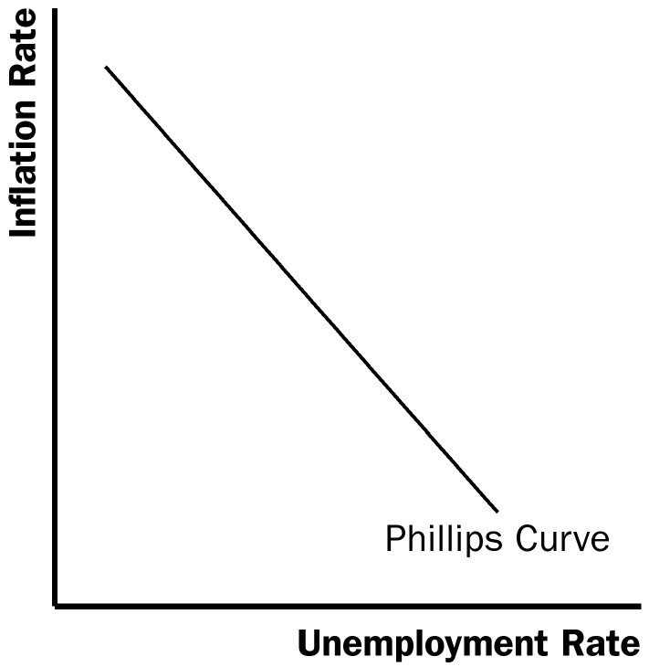

Figure 1

To see how policy can move the economy from a point with high inflation to a point with low inflation, suppose the economy begins at point A in Figure 2. If policy is used to reduce aggregate demand (such as a decrease in the money supply or a decrease in government purchases), the aggregate-demand curve shifts from AD₁ to AD₂, and the economy moves from point A to point B with lower inflation, a reduction in real GDP, and an increase in the unemployment rate.

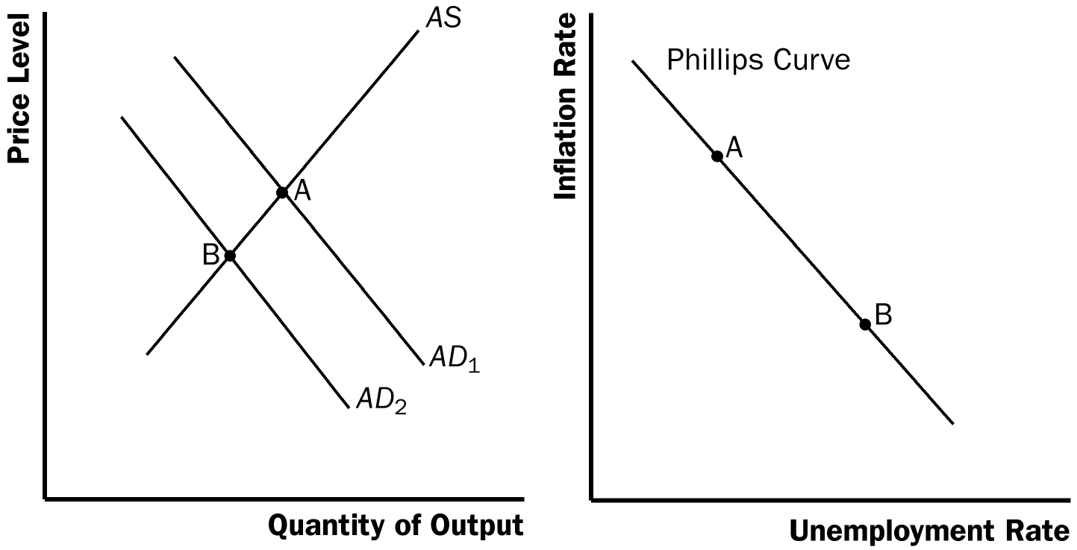

Figure 2

2. Figure 3 shows the short-run Phillips curve and the long-run Phillips curve. The curves are different because in the long run, monetary policy has no effect on unemployment, which tends toward its natural rate. However, in the short run, monetary policy can affect the unemployment rate. An increase in the growth rate of money raises actual inflation above expected inflation, causing firms to produce more since the short-run aggregate supply curve is positively sloped, which reduces unemployment temporarily.

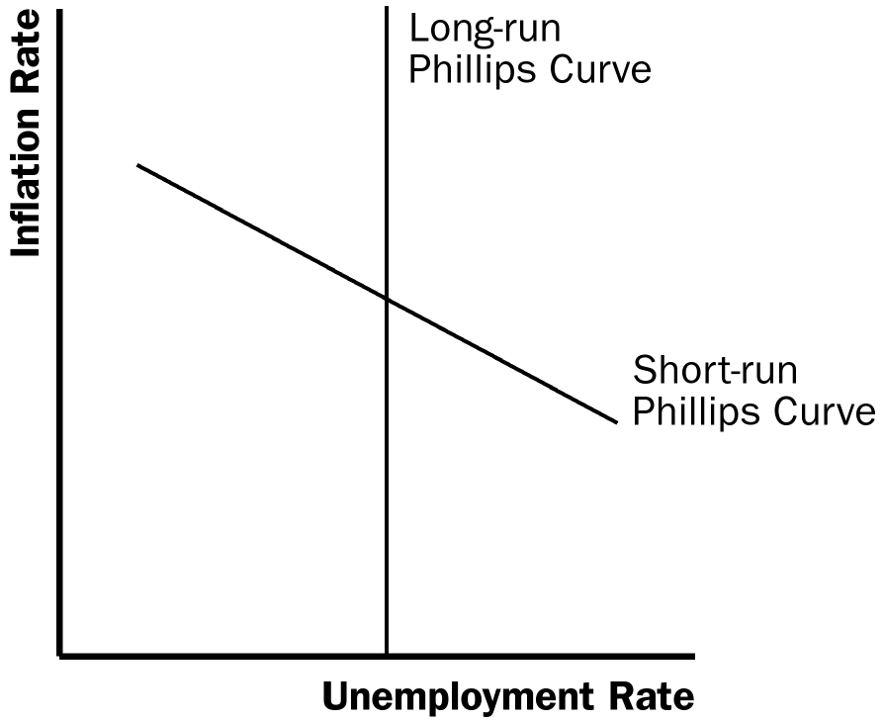

Figure 3

3. Examples of favorable shocks to aggregate supply include improved productivity and a decline in oil prices. Either shock shifts the aggregate-supply curve to the right, increasing output and reducing the price level, moving the economy from point A to point B in Figure 4. As a result, the Phillips curve shifts to the left, as the figure shows.

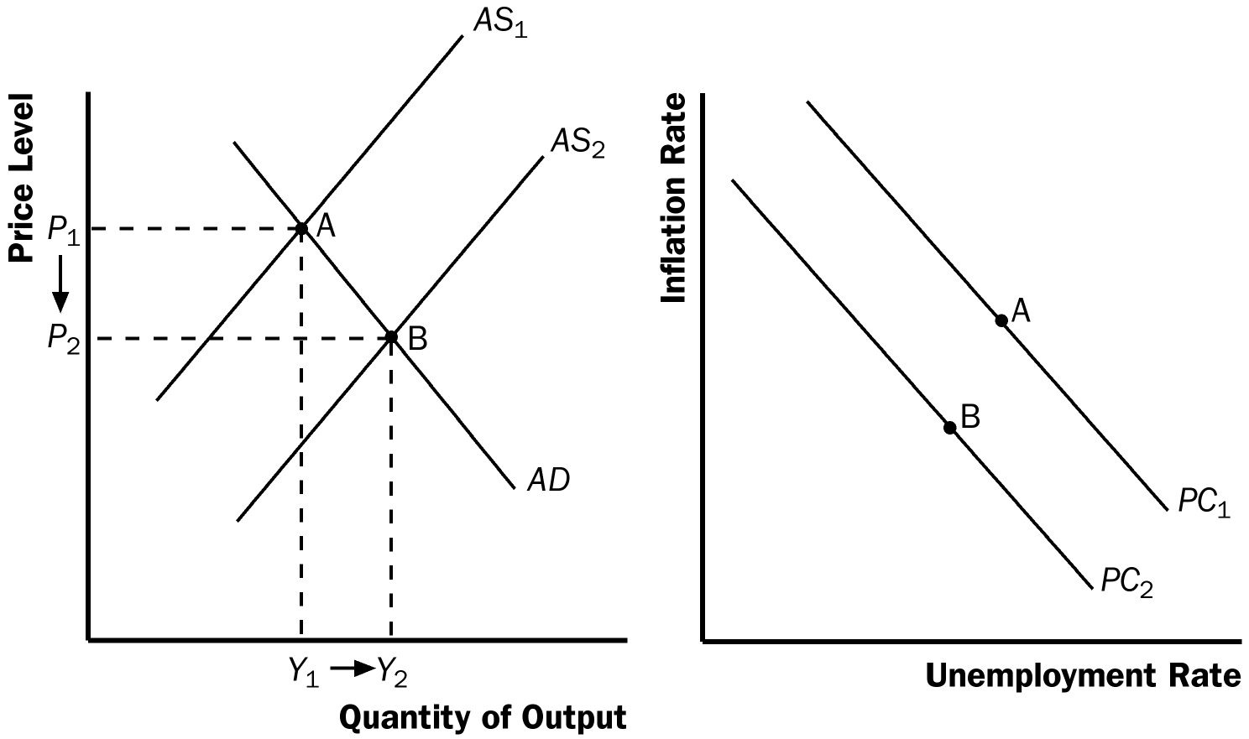

Figure 4

4. The sacrifice ratio is the number of percentage points of annual output lost in the process of reducing inflation by 1 percentage point. The credibility of the Fed’s commitment to reduce inflation might affect the sacrifice ratio because it affects the speed at which expectations of inflation adjust. If the Fed’s commitment to reduce inflation is credible, people will reduce their expectations of inflation quickly, the short-run Phillips curve will shift downward, and the cost of reducing inflation will be low in terms of lost output. But if the Fed is not credible, people will not reduce their expectations of inflation quickly, and the cost of reducing inflation will be high in terms of lost output.

Questions for Review

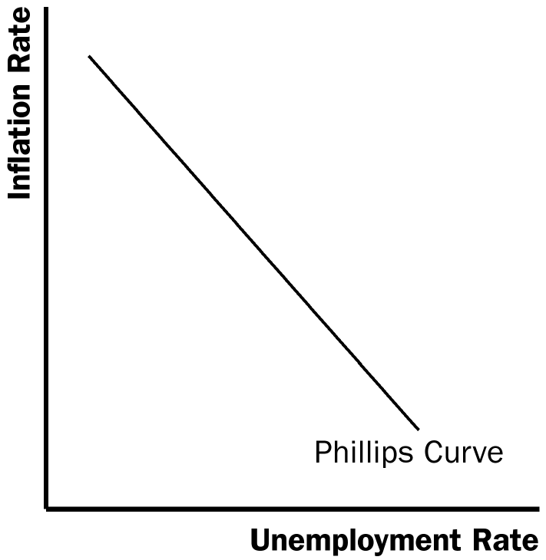

Figure 5

1. Figure 5 shows the short-run trade-off between inflation and unemployment. The Fed can move the economy from one point on this curve to another by changing the money supply. An increase in the money supply reduces the unemployment rate and increases the inflation rate, while a decrease in the money supply increases the unemployment rate and decreases the inflation rate.

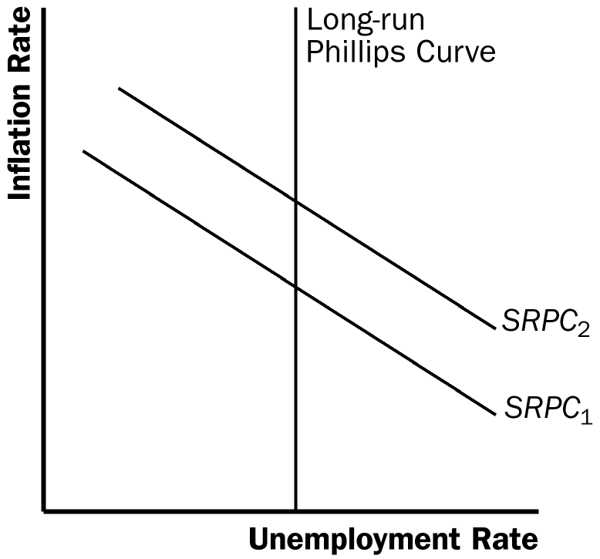

Figure 6

2. Figure 6 shows the long-run trade-off between inflation and unemployment. In the long run, there is no trade-off, as the economy must return to the natural rate of unemployment on the long-run Phillips curve. In the short run, the economy can move along a short-run Phillips curve, like SRPC₁ shown in the figure. But over time (as inflation expectations adjust) the short-run Phillips curve will shift to return the economy to the long-run Phillips curve, for example shifting from SRPC₁ to SRPC₂.

3. The natural rate of unemployment is natural because it is beyond the influence of monetary policy. The rate of unemployment will move to its natural rate in the long run, regardless of the inflation rate.

The natural rate of unemployment might differ across countries because countries have varying degrees of union power, minimum-wage laws, collective-bargaining laws, unemployment insurance, job-training programs, and other factors that influence labor-market conditions.

4. If a drought destroys farm crops and drives up the price of food, the short-run aggregate-supply curve shifts to the left and the short-run Phillips curve shifts to the right, because the costs of production have increased. The higher short-run Phillips curve means the inflation rate will be higher for any given unemployment rate.

5. When the Fed decides to reduce inflation, the economy moves down along the short-run Phillips curve, as shown in Figure 7. Beginning at point A on short-run Phillips curve SRPC₁, the economy moves down to point B as inflation declines. Once people's expectations adjust to the lower rate of inflation, the short-run Phillips curve shifts to SRPC₂, and the economy moves to point C. The short-run costs of disinflation, which arise because the unemployment rate is temporarily above its natural rate, could be reduced if the Fed's action was credible, so that expectations would adjust more rapidly.

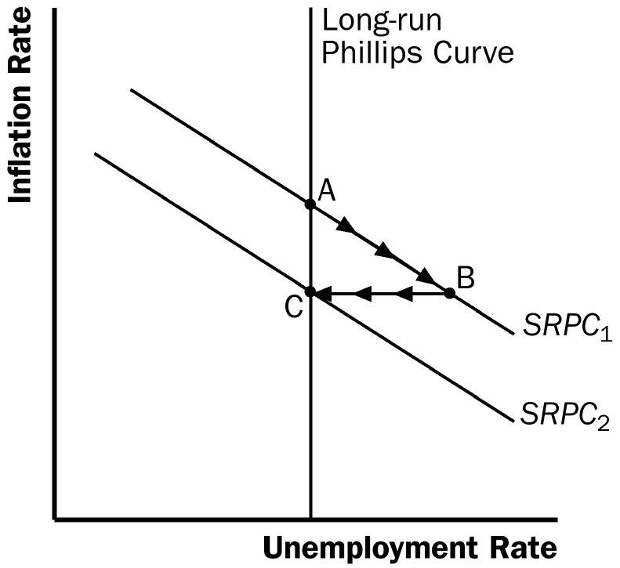

Figure 7

Quick Check Multiple Choice
1. b
2. d
3. c
4. a
5. b
6. d

Problems and Applications

1. Figure 8 shows two different short-run Phillips curves depicting these four points. Points a and d are on SRPC₁ because both have expected inflation of 3%. Points b and c are on SRPC₂ because both have expected inflation of 5%.

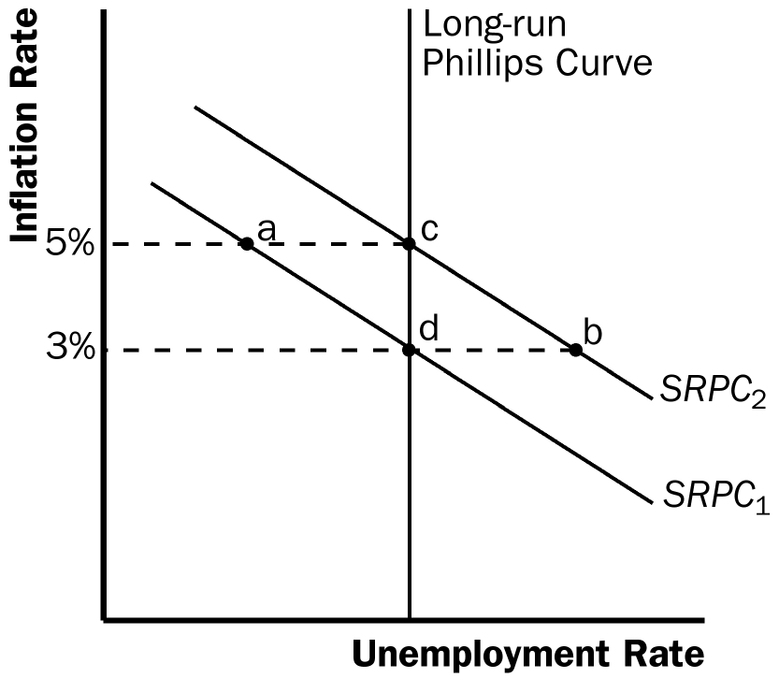

Figure 8

2. a. A rise in the natural rate of unemployment shifts both the long-run Phillips curve and the short-run Phillips curve to the right, as shown in Figure 9. The economy is initially on LRPC₁ and SRPC₁ at an inflation rate of 3%, which is also the expected rate of inflation. The increase in the natural rate of unemployment shifts the long-run Phillips curve to LRPC₂ and the short-run Phillips curve to SRPC₂, with the expected rate of inflation remaining equal to 3%.

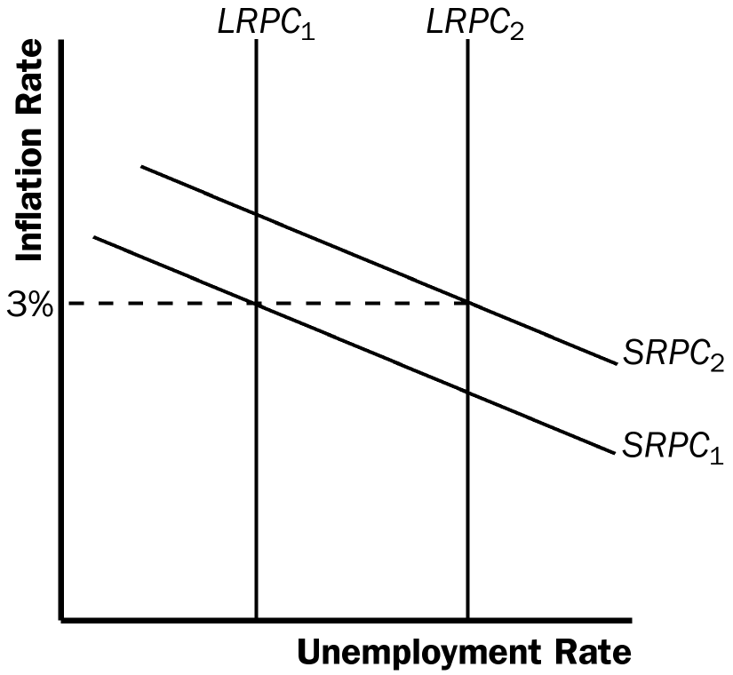

Figure 9

b. A decline in the price of imported oil shifts the short-run Phillips curve to the left, as shown in Figure 10, from SRPC₁ to SRPC₂. For any given unemployment rate, the inflation rate is lower, because oil is such a significant aspect of production costs in the economy.

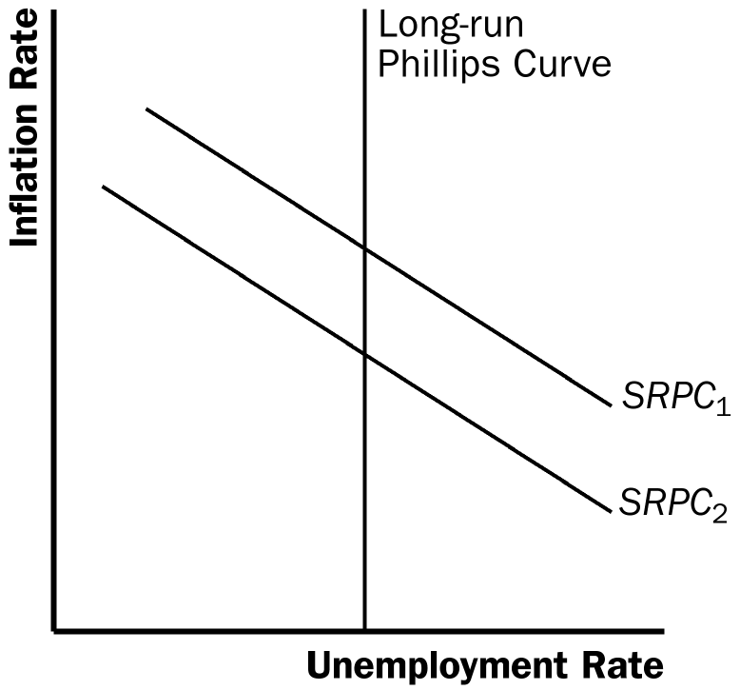

Figure 10

c. A rise in government spending represents an increase in aggregate demand, so it moves the economy along the short-run Phillips curve, as shown in Figure 11. The economy moves from point A to point B, with a decline in the unemployment rate and an increase in the inflation rate.

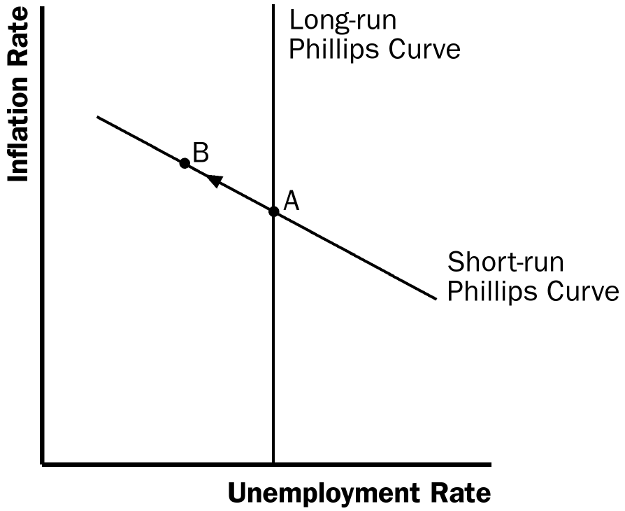

Figure 11

d. A decline in expected inflation causes the short-run Phillips curve to shift to the left, as shown in Figure 12. The lower rate of expected inflation shifts the short-run Phillips curve from SRPC₁ to SRPC₂.

Figure 12

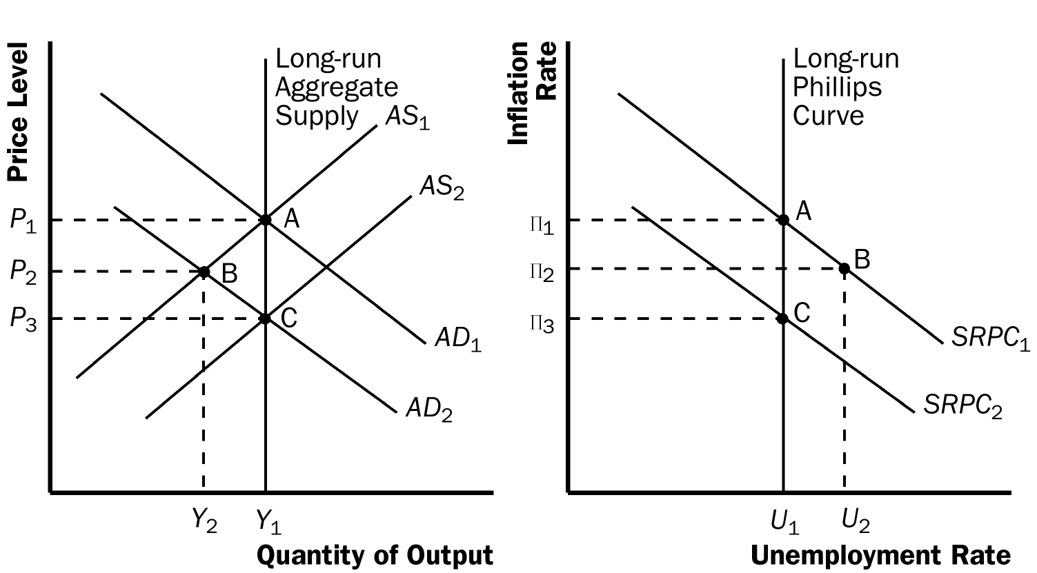

Figure 13

3. a. Figure 13 shows how a reduction in consumer spending causes a recession in both an aggregate-supply/aggregate-demand diagram and a Phillips-curve diagram. In both diagrams, the economy begins at full employment at point A. The decline in consumer spending reduces aggregate demand, shifting the aggregate-demand curve to the left from AD₁ to AD₂. The economy initially remains on the short-run aggregate-supply curve AS₁, so the new equilibrium occurs at point B. The movement of the aggregate-demand curve along the short-run aggregate-supply curve leads to a movement along short-run Phillips curve SRPC₁, from point A to point B. The lower price level in the aggregate-supply/aggregate-demand diagram corresponds to the lower inflation rate in the Phillips-curve diagram. The lower level of output in the aggregate-supply/aggregate-demand diagram corresponds to the higher unemployment rate in the Phillips-curve diagram.

b. As expected inflation falls over time, the short-run aggregate-supply curve shifts to the right from AS₁ to AS₂, and the short-run Phillips curve shifts to the left from SRPC₁ to SRPC₂. In both diagrams, the economy eventually gets to point C, which is back on the long-run aggregate-supply curve and long-run Phillips curve. After the recession is over, the economy faces a better set of inflation-unemployment combinations.

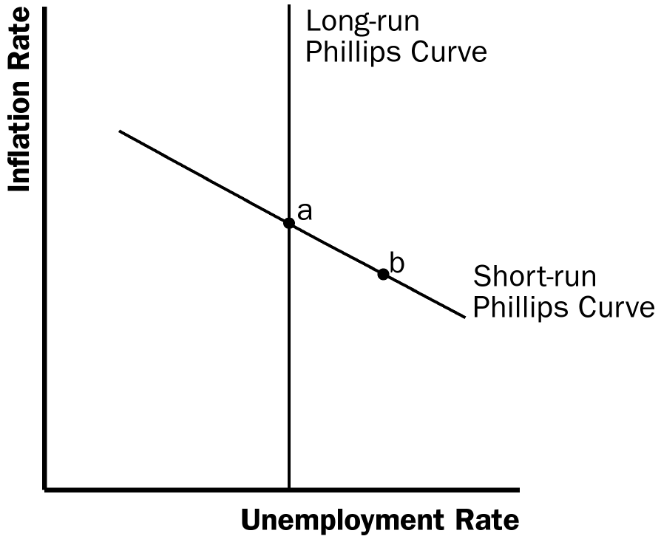

Figure 14

4. a. Figure 14 shows the economy in long-run equilibrium at point a, which is on both the long-run and short-run Phillips curves.

b. A wave of business pessimism reduces aggregate demand, moving the economy to point b in the figure. The unemployment rate increases and the inflation rate declines. If the Fed undertakes expansionary monetary policy, it can increase aggregate demand, offsetting the pessimism and returning the economy to point a, with the initial inflation rate and unemployment rate.

c. Figure 15 shows the effects on the economy if the price of imported oil rises. The higher price of imported oil shifts the short-run Phillips curve to the right from SRPC ₁ to SRPC ₂. The economy moves from point a to point c, with a higher inflation rate and higher unemployment rate. If the Fed engages in expansionary monetary policy, it can return the economy to its original unemployment rate at point d, but the inflation rate will be higher. If the Fed engages in contractionary monetary policy, it can return the economy to its original inflation rate at point e, but the unemployment rate will be higher. This situation differs from that in part (b) because in part (b) the economy stayed on the same short-run Phillips curve, but in part (c) the economy moved to a higher short-run Phillips curve, which gives policymakers a less favorable trade-off between inflation and unemployment.

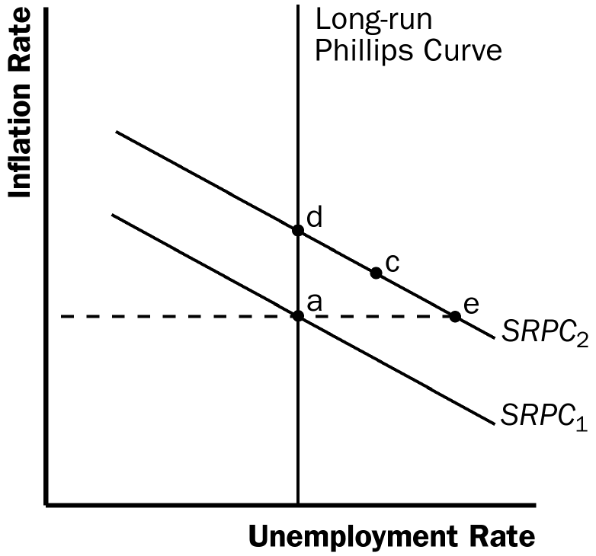

Figure 15

5. Economists who believe that expectations adjust quickly in response to changes in policy would be more likely to favor using contractionary policy to reduce inflation than economists with the opposite views. If expectations adjust quickly, the costs of reducing inflation (in terms of lost output) will be relatively small. Thus, Milton would be more in favor of following a policy to reduce inflation than would James.

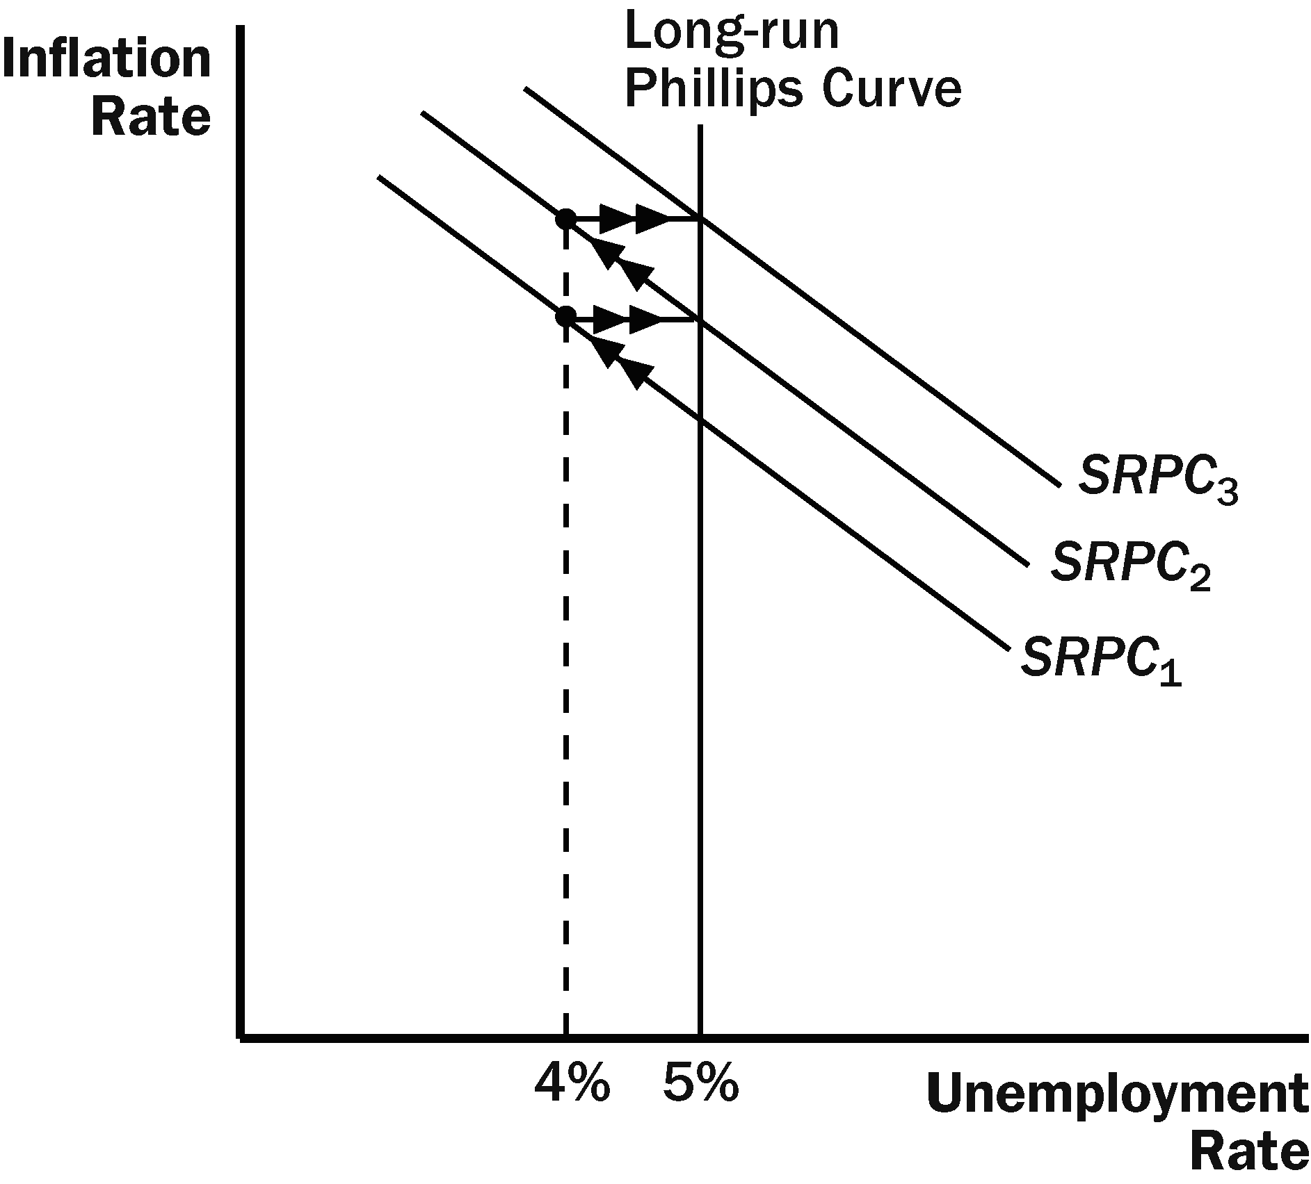

Figure 16

6. If the Fed acts on its belief that the natural rate of unemployment is 4%, when the natural rate is in fact 5%, the result will be a spiraling up of the inflation rate, as shown in Figure 16. Starting from a point on the long-run Phillips curve, with an unemployment rate of 5%, the Fed will believe that the economy is in a recession, because the unemployment rate is greater than its estimate of the natural rate. Therefore, the Fed will increase the money supply, moving the economy along the short-run Phillips curve SRPC₁. The inflation rate will rise and the unemployment rate will fall to 4%. As the inflation rate rises over time, expectations of inflation will rise, and the short-run Phillips curve will shift to the right to SRPC₂. This process will continue, and the inflation rate will spiral upwards.

The Fed may eventually realize that its estimate of the natural rate of unemployment is wrong by examining the rising trend in the inflation rate.

7. a. If wage contracts have short durations, a recession induced by contractionary monetary policy will be less severe, because wage contracts can be adjusted more rapidly to reflect the lower inflation rate. This will allow a more rapid movement of the short-run aggregate-supply curve and short-run Phillips curve to restore the economy to long-run equilibrium.

b. If there is little confidence in the Fed's determination to reduce inflation, a recession induced by contractionary monetary policy will be more severe. It will take longer for people's inflation expectations to adjust downwards.

c. If expectations of inflation adjust quickly to actual inflation, a recession induced by contractionary monetary policy will be less severe. In this case, people's expectations adjust quickly, so the short-run Phillips curve shifts quickly to restore the economy to long-run equilibrium at the natural rate of unemployment.
Long-Run
Phillips Curve
Long-Run
Aggregate Supply
Price Level
Inflation Rate

AS₂
AS₁
• C
•C

•A
•B
• B
AD₃
• A
SRPC₂

AD₁
SRPC₁

AD₂

Unemployment Rate
Quantity of Output

Figure 17

8. a. As shown in the left diagram of Figure 17, equilibrium output and employment will fall. However, the effects on the price level and inflation rate will be ambiguous. The fall in aggregate demand puts downward pressure on prices, while the decline in short-run aggregate supply pushes prices up. The diagram on the right side of Figure 17 assumes that the inflation rate rises.

b. The Fed would have to use expansionary monetary policy to keep output and employment at their natural rates. Aggregate demand would have to shift to AD₃.

c. The Fed may not want to pursue this action because it will lead to a rise in the inflation rate as shown by point C.

